APPENDIX 3
MASTER-LEVEL RESEARCH PLAN (FORM)
(Enclosed herewith is Project no. /ĐA-TĐT dated January…2022 approved by the President of TDTU)

A research plan (book binding, a cover page, a table of contents, and references) is required to include the followings
- Objectives/Expected learning outcomes from the M.A. program
- Rationale for choosing the educational institution
- Introduction to the Bachelor-level thesis or graduation project (if necessary)
- Master-level research plan
Candidates may present the followings
  - Research ideas
- The significance and the rationale of the research
- Review of previous literature and related theories
  - Proposed research objectives and methods
- Objectives of the proposed research
- Potential research participants and scope(s) of the proposed research
- Intended research methods
- Suggested timeline for conducting the proposed research
  - References
  - Request for thesis supervisor (if any, the requested supervisor must be a full-time lecturer of TDTU who holds a doctoral degree or higher in the field).

VIETNAM GENERAL CONFEDERATION OF LABOR
TON DUC THANG UNIVERSITY

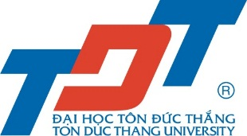

RESEARCH PLAN

RESEARCH TITLE

APPLICATION FOR A MASTER PROGRAM

Major:….
Major code:

Candidate name:

HO CHI MINH CITY, .....

